**“AITor” - EDUCATION PLATFORM – A PERSONALIZED STUDENT PERFORMANCE ANALYZER AND RECOMMENDATION SYSTEM**

2022-017

Project Status Document - 2

Thammita D.H.M.M.P– IT19120362

B.Sc. (Hons) in Information Technology specializing in Software Engineering

Department of Software Engineering

Sri Lanka Institute of Information Technology

Sri Lanka

January 2022

# DECLARATION

We declare that this is our own work, and this proposal does not incorporate without acknowledgement any material previously submitted for a degree or diploma in any other university or Institute of higher learning and to the best of our knowledge and belief it does not contain any material previously published or written by another person except where the acknowledgement is made in the text.

|  |  |  |
| --- | --- | --- |
| Name | Student ID | Signature |
| Thammita D.H.M.M.P | IT19120362 |  |

The above candidates are carrying out research for the undergraduate Dissertation

under my supervision.

Date:

11/13/2022

Contents

DECLARATION ii

1. Microsoft Teams chats and Meetings with supervisor/co-supervisor/external supervisor 4

1.1. Initial Teams group for research team – team creation 4

1.2. Research team members only MS teams’ creation 6

2. WhatsApp Chat Group for Continuous Communication with Team Members with Supervisor/Co-Supervisor/External Supervisor. 8

2.1. WhatsApp Group Creation 8

2.2. Continuous Commination through WhatsApp Chat Group 9

3. Scheduled MS Teams discussions 15

3.1. Weekly meeting with team members 15

3.2. Bi-Weekly meeting with Co-Supervisor/External-Supervisor for research progress evaluation 17

4. Research Paper Presentations 19

4.1. IEEE UEMCON 2022 19

5. Project planner 21

5.1. Boards 21

5.2. Charts 24

5.2.1. Overall Project Task Overview 24

5.2.2. Overview of Tasks Of Thammita D.H.M.M.P(IT19120362) 26

6. Project Gantt chart 27

7. Work breakdown chart 28

8. User task allocation details 29

Allocated task 29

Predicted time 29

Actual time spent 29

1. Key learning area Identifier Dataset creation 29

01/04/2022 – 30/04/2022 (30 days) 29

20 days 29

2. Learning area Identifier algorithm implementation 29

15/04/2022 – 30/04/2022 (15 days) 29

21 days 29

3. Learning area Identifier API implementation 29

01/05/2022 – 06/05/2022 (6 days) 29

1 day 29

4. Learning material recommender model implementation using cosine similarity 29

30/04/2022 – 11/05/2022 (11 days) 29

6 days 29

9. GitLab Charts 30

9.1. Commits To Master Branch 30

9.2. Commits By Thammita D.H.M.M.P(IT19120362) 30

9.3. Commits To dev/it19120362 32

# Microsoft Teams chats and Meetings with supervisor/co-supervisor/external supervisor

## Initial Teams group for research team – continuous communication

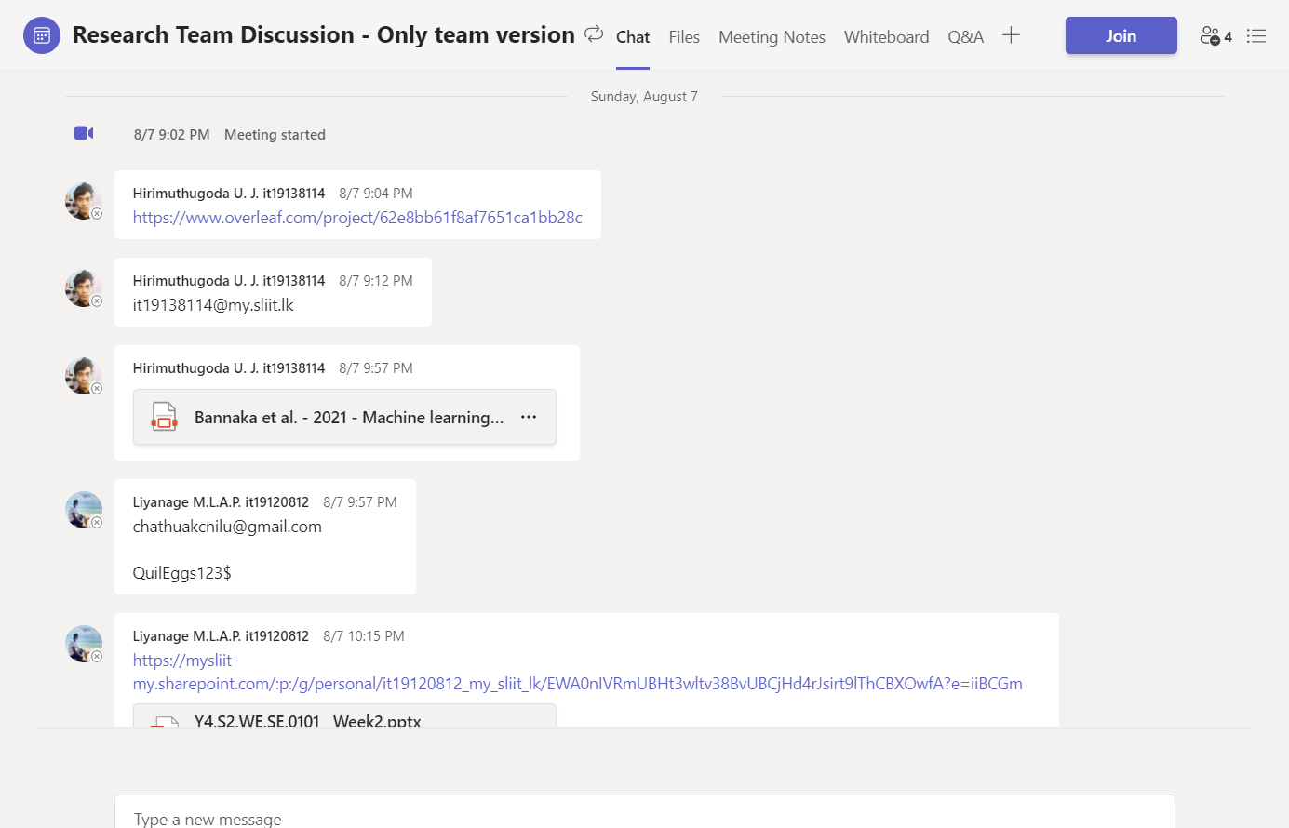

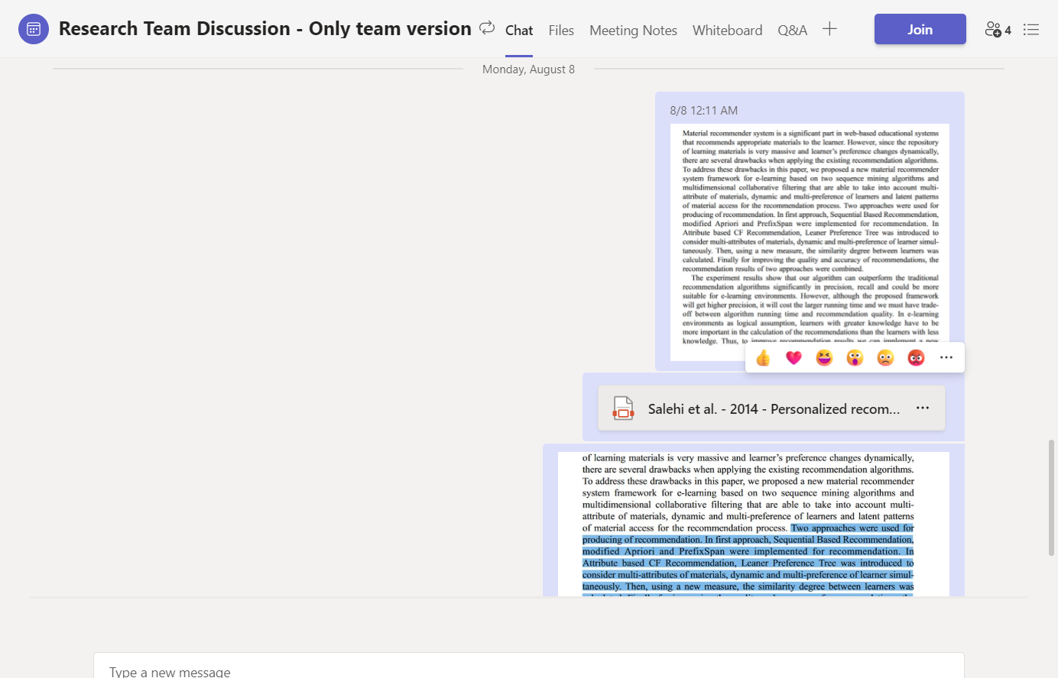

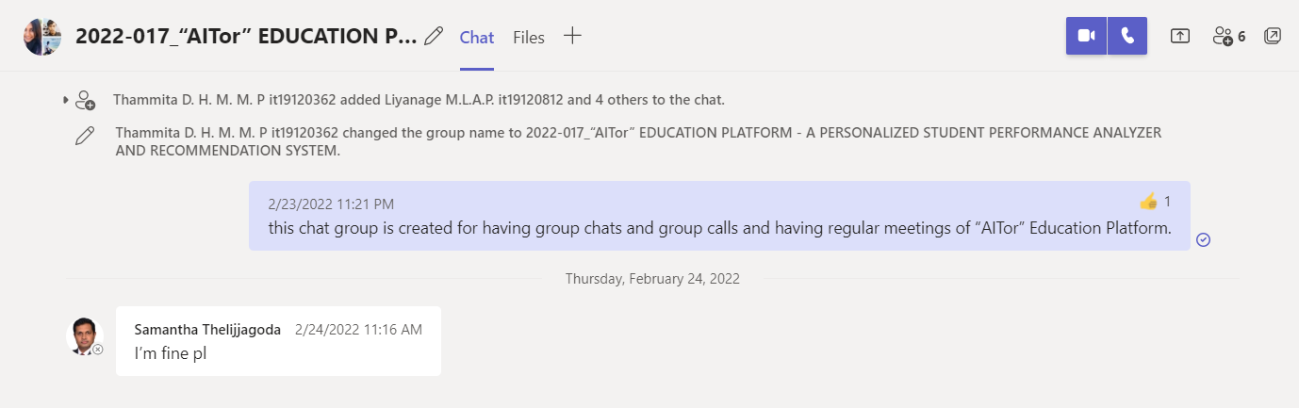

Figure :: Microsoft Teams , Team Creation for meetings with Supervisor/Co-Supervisor/External Supervisors

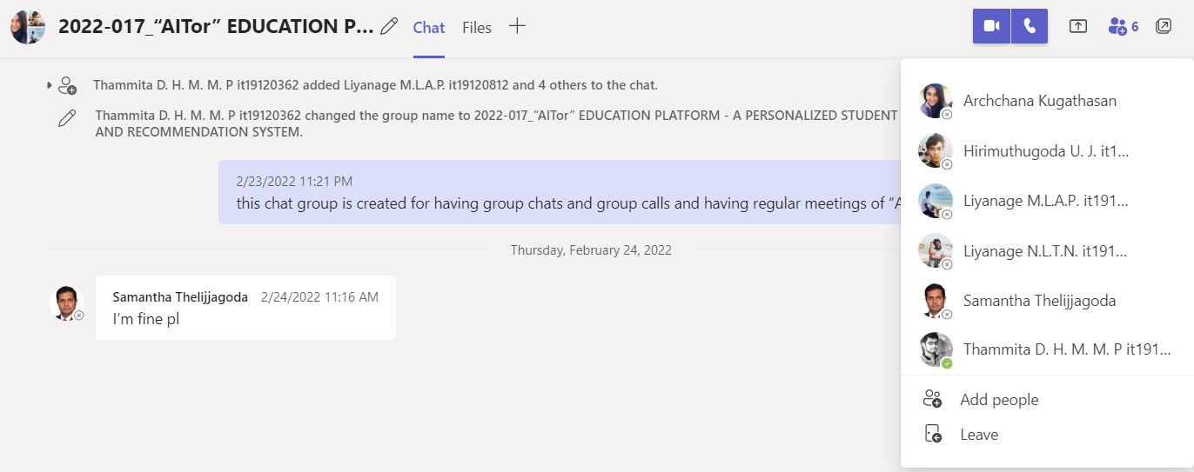

## Research team members only MS teams’ continuous communication

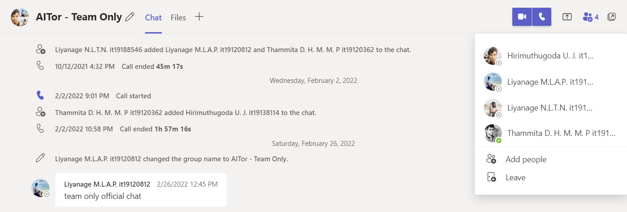

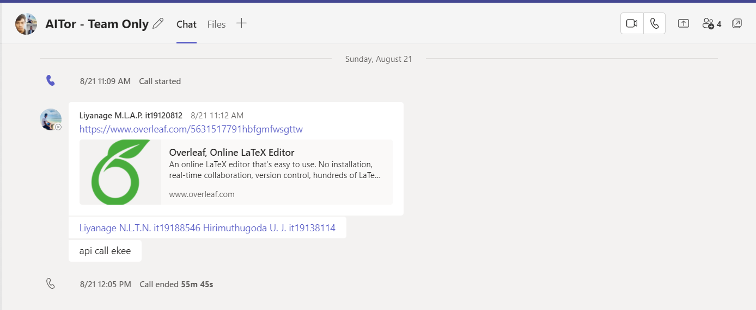

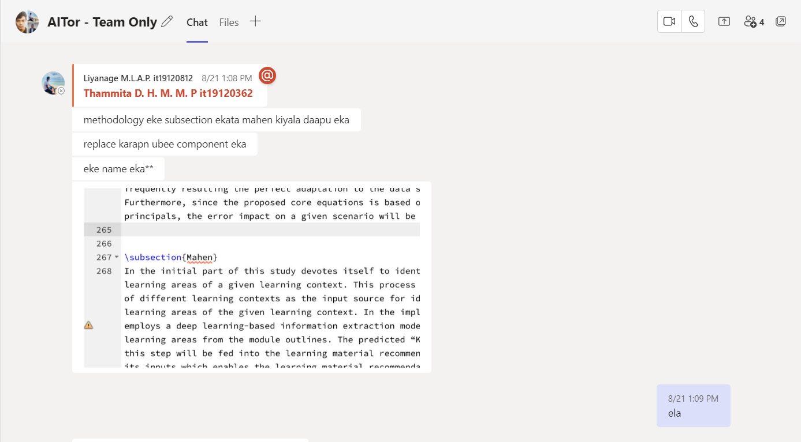

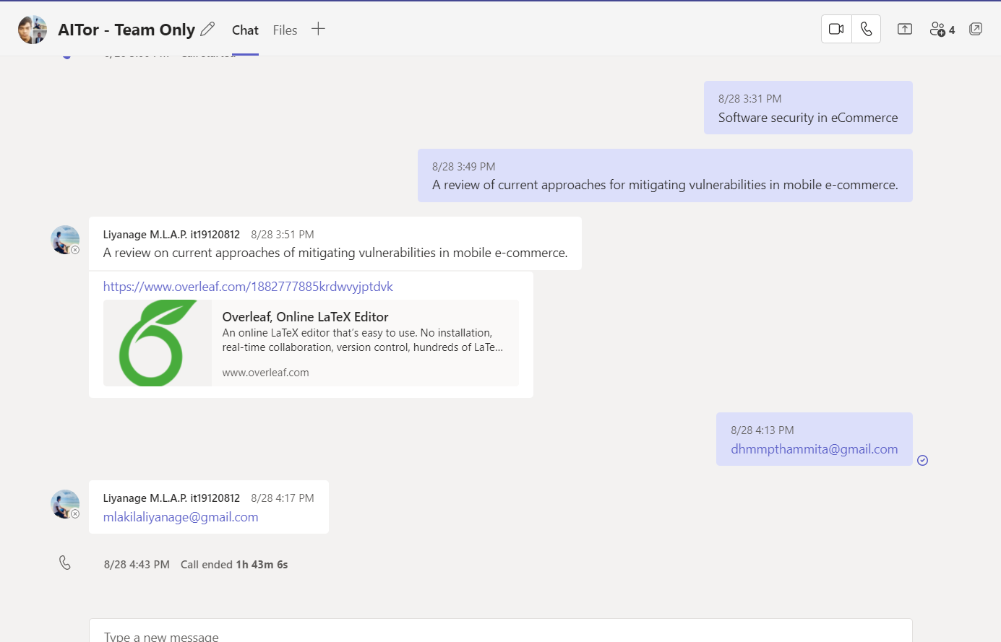

# WhatsApp Chat Group for Continuous Communication with Team Members with Supervisor/Co-Supervisor/External Supervisor.

## Continuous Commination through WhatsApp Chat Group

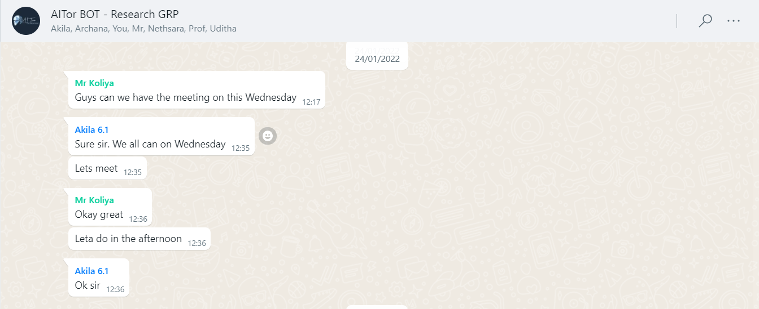

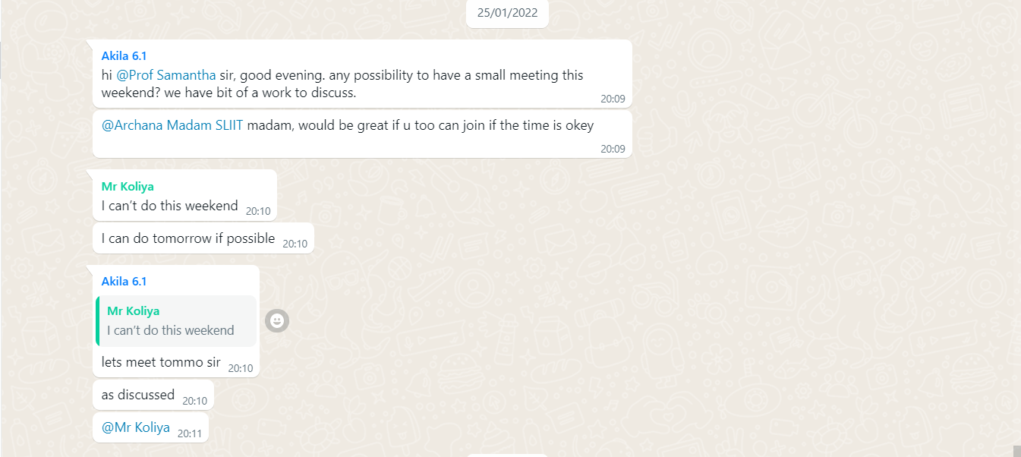

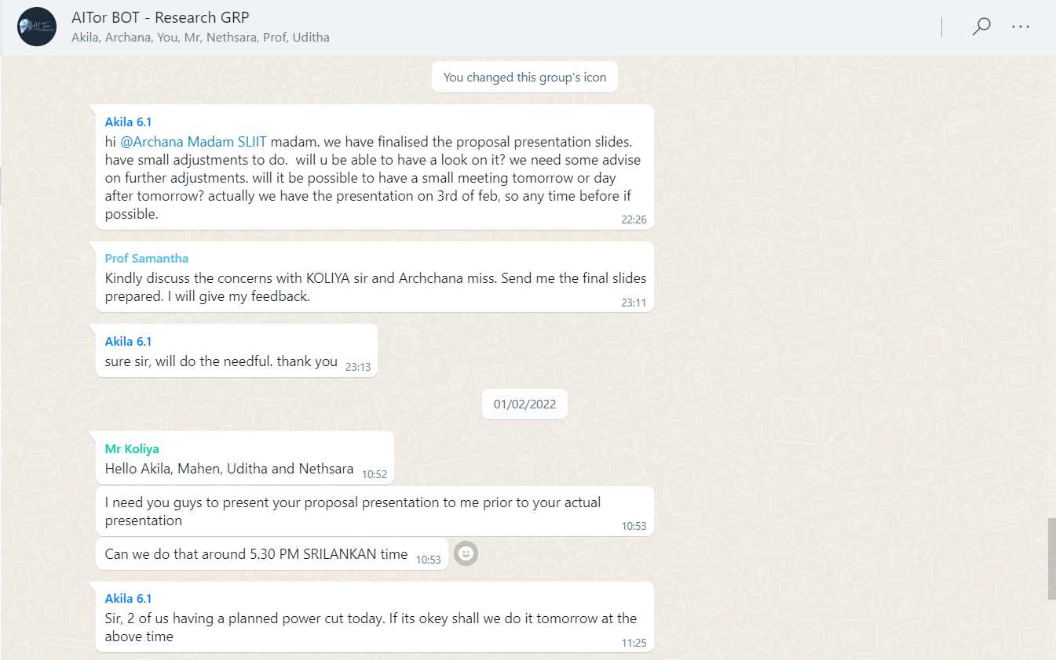

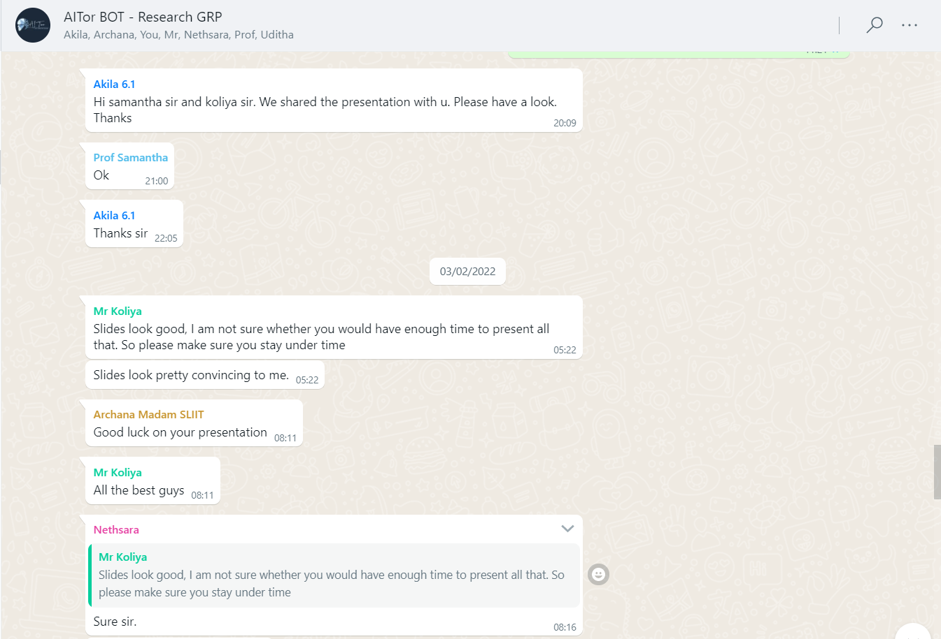

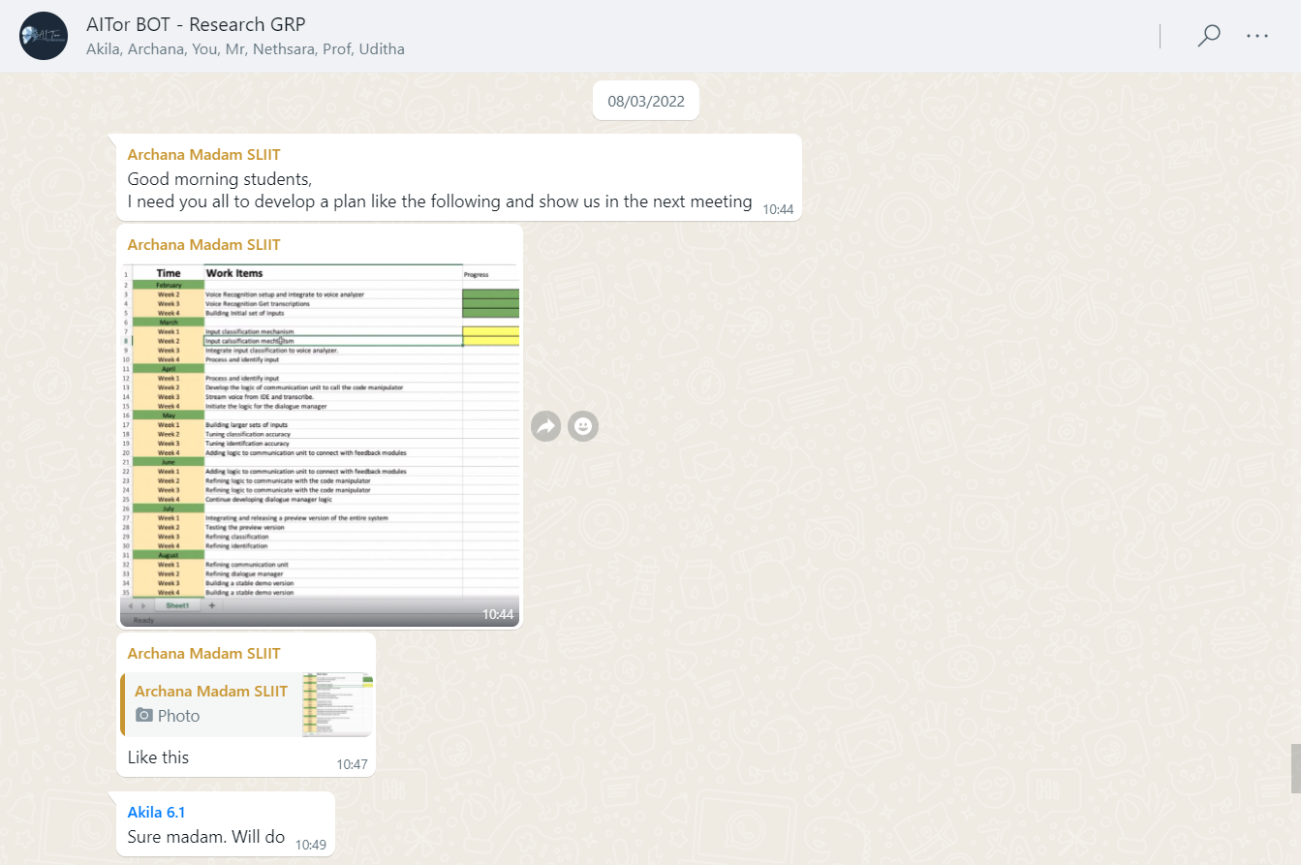

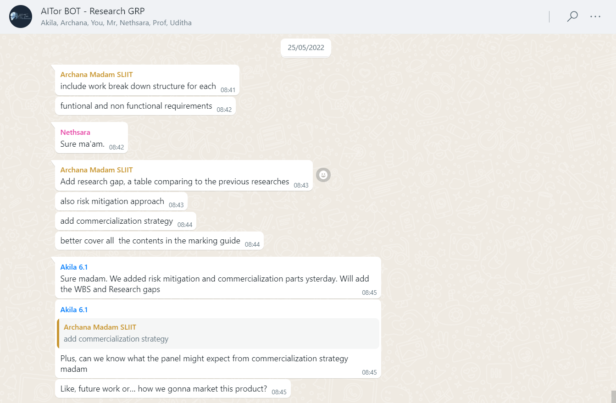

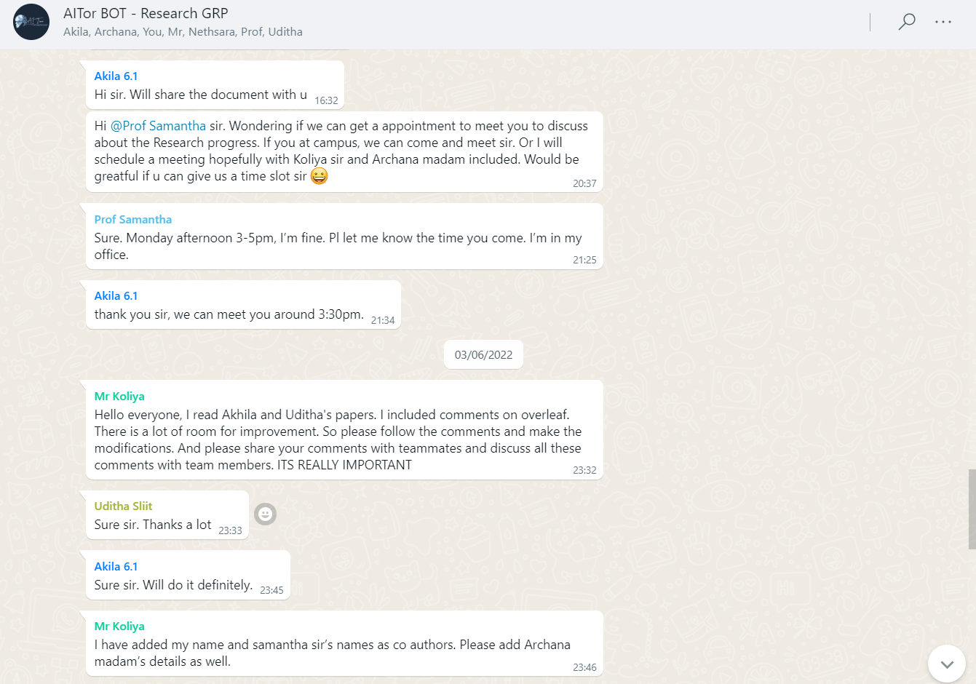

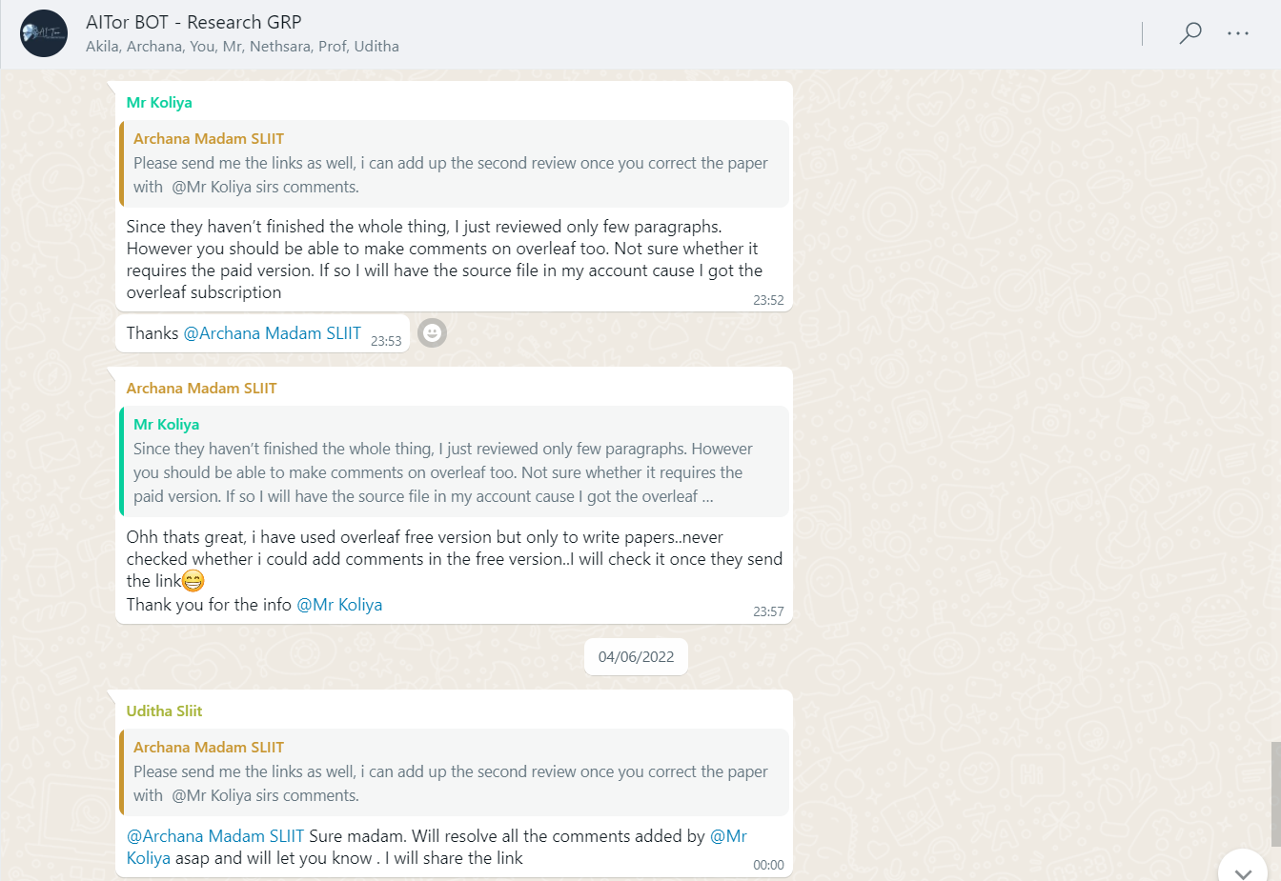

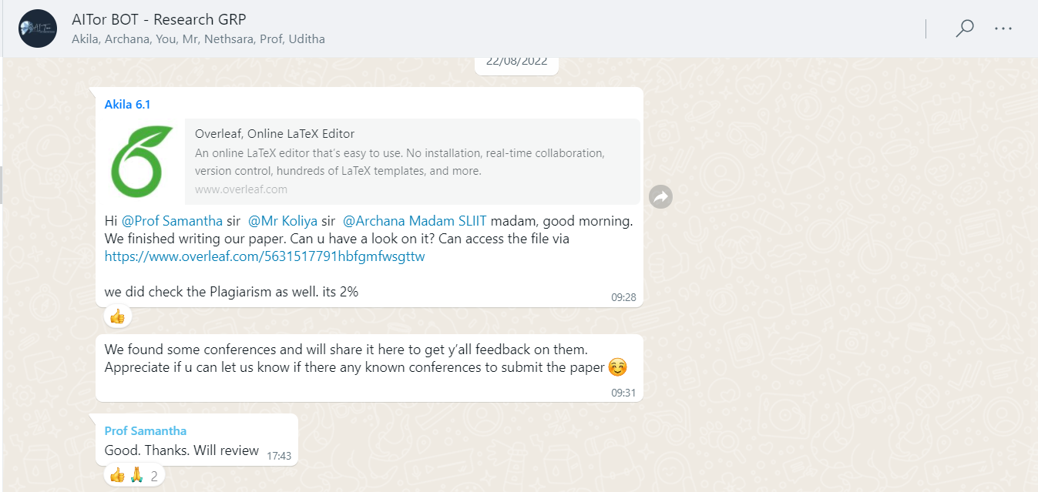

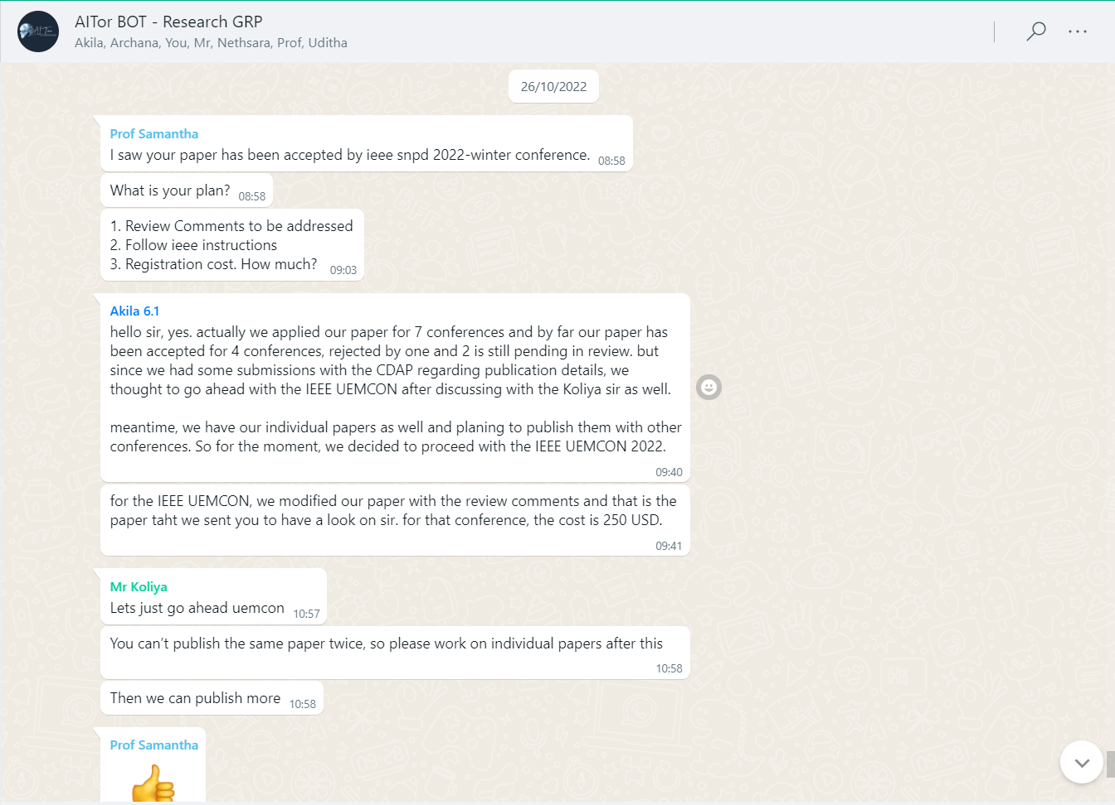

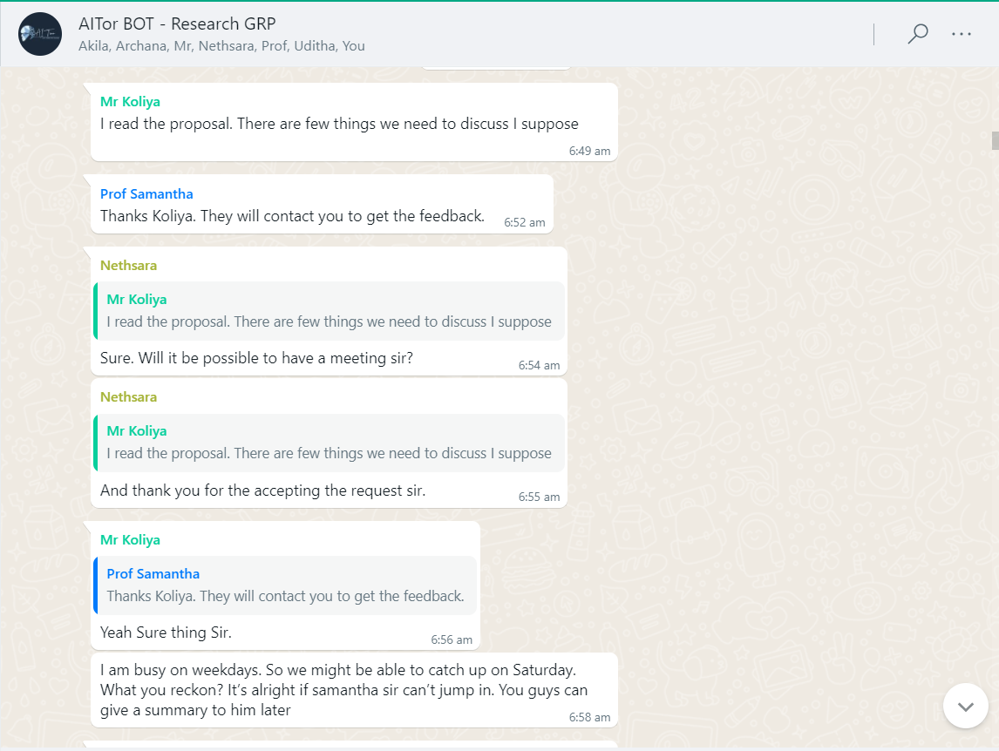

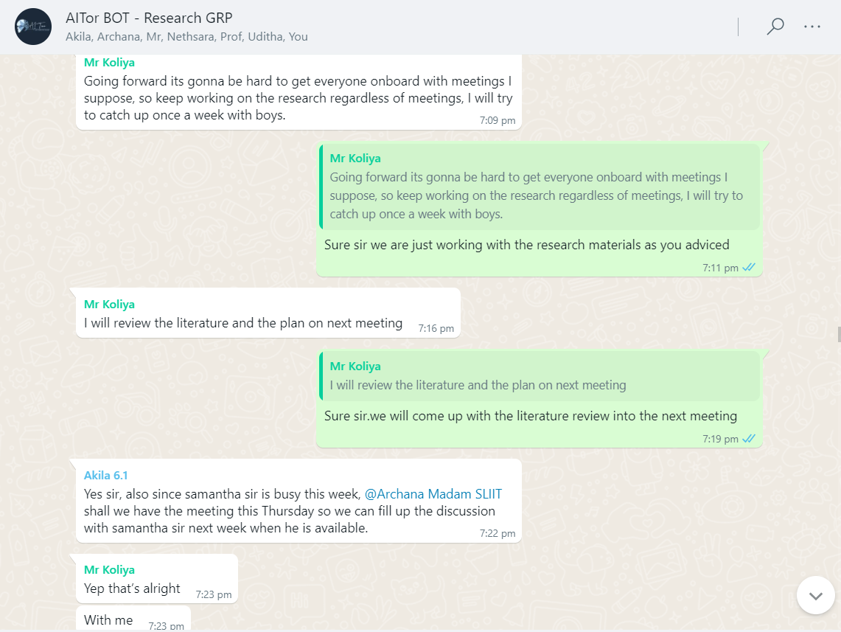

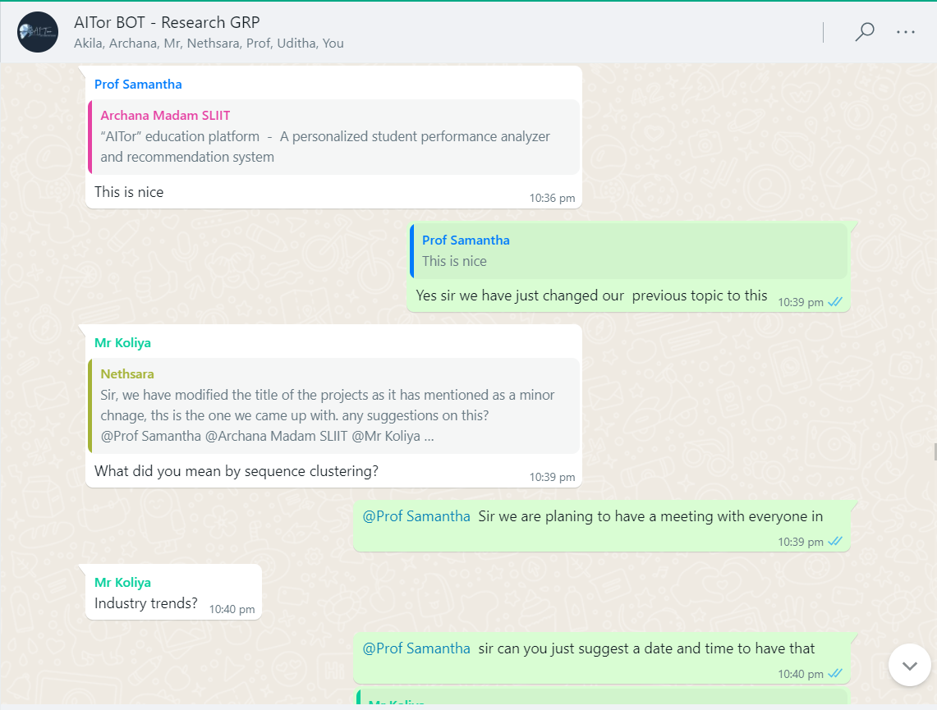

# Scheduled MS Teams discussions

## Weekly meeting with team members

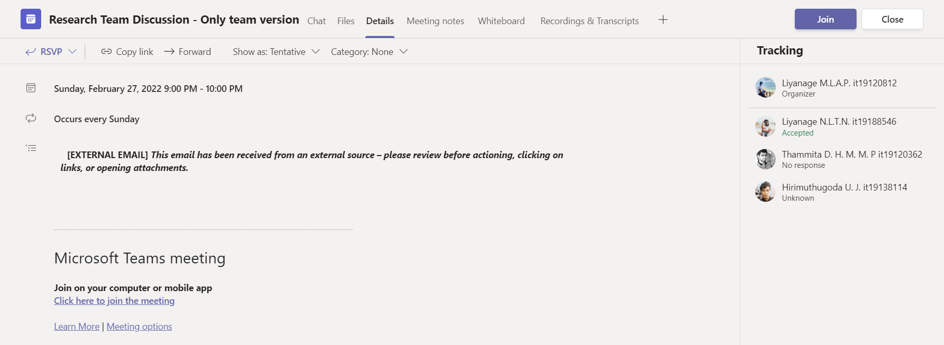

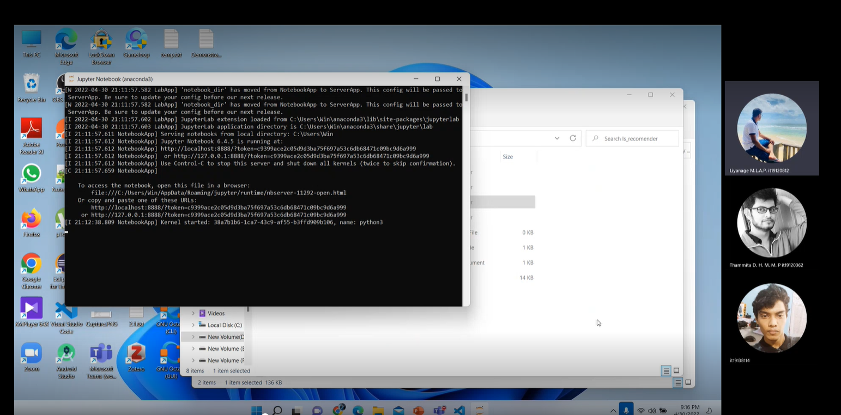

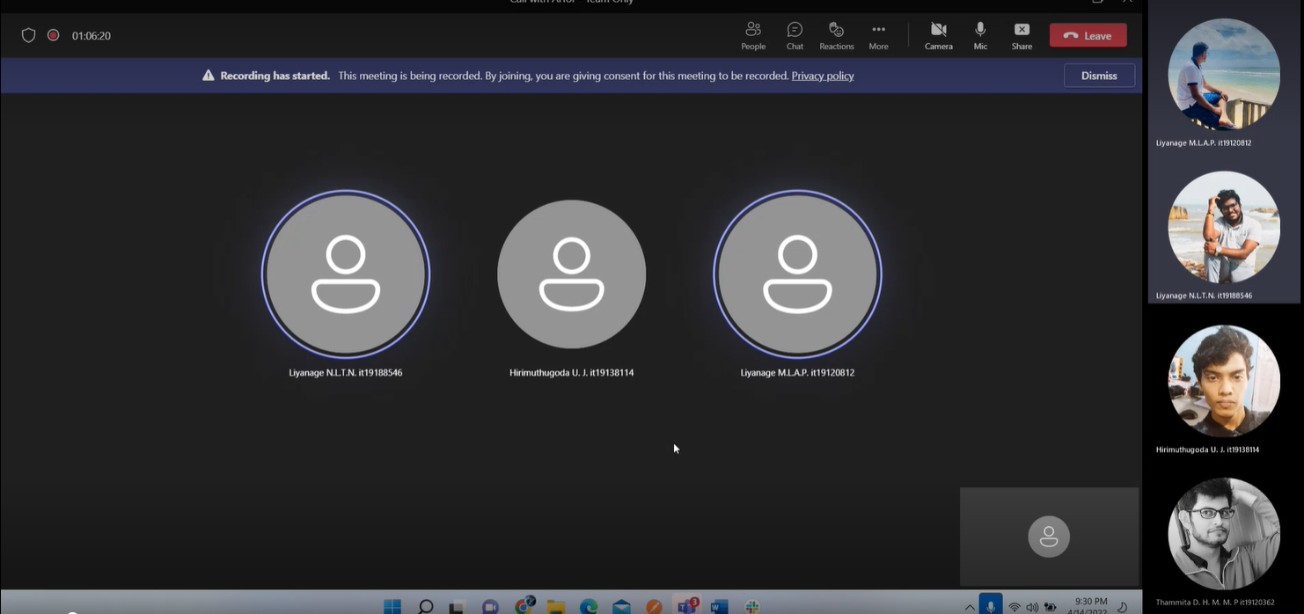

## Bi-Weekly meeting with Co-Supervisor/External-Supervisor for research progress evaluation

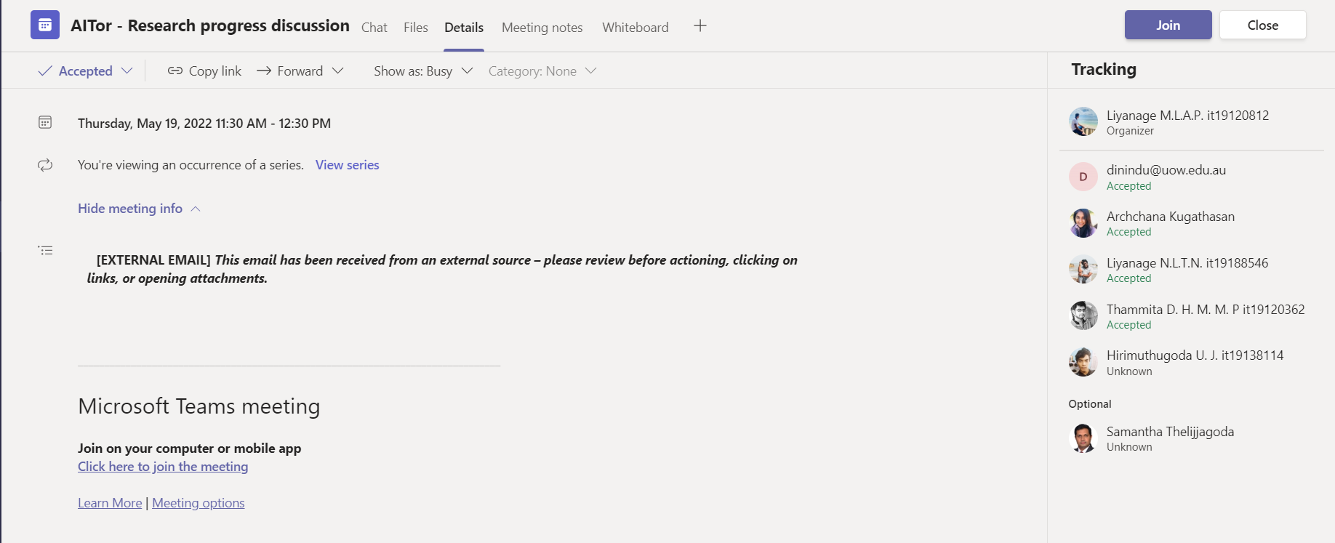

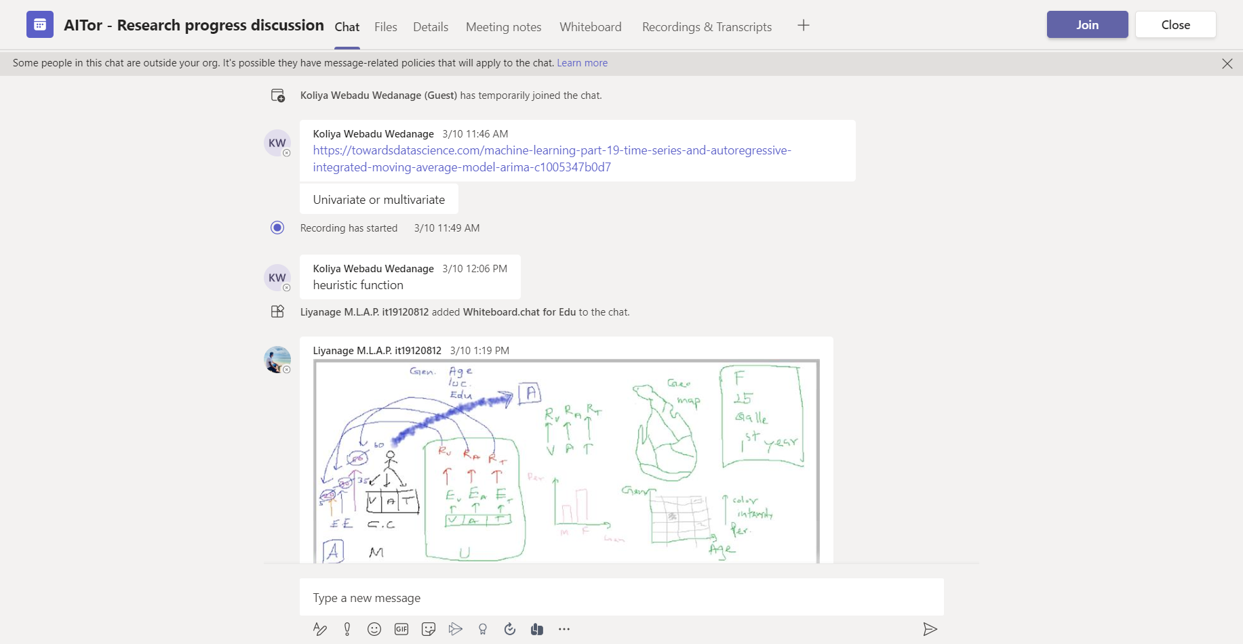

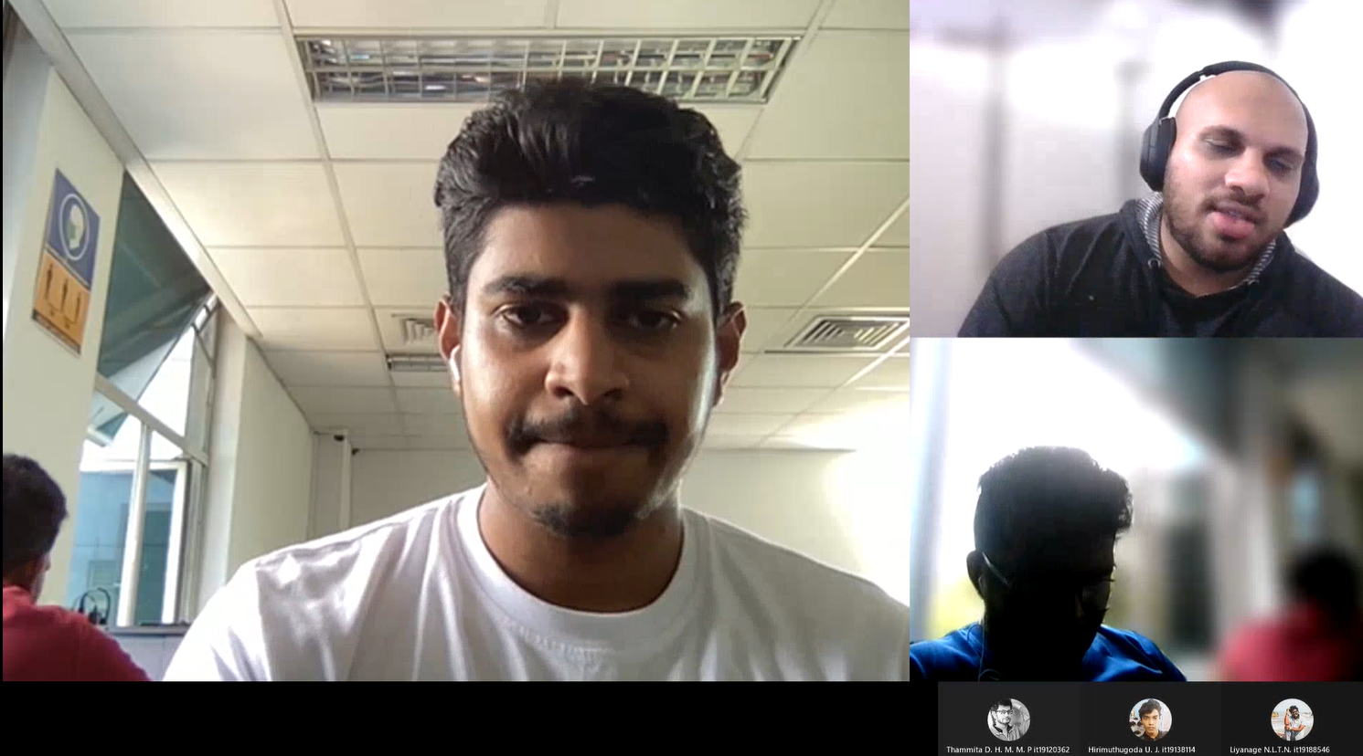

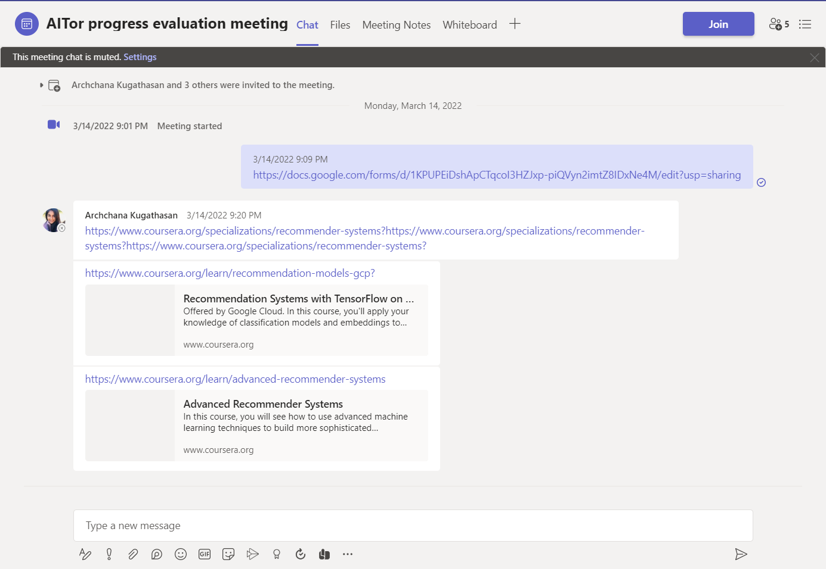

# Research Paper Presentations

## IEEE UEMCON 2022

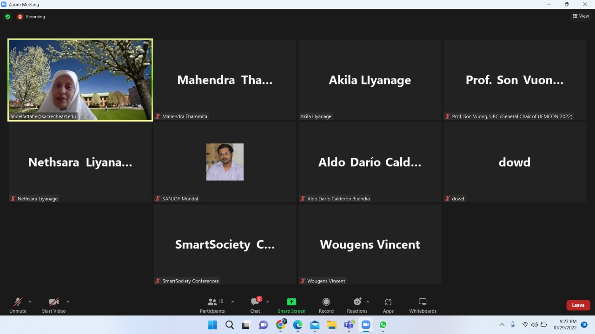

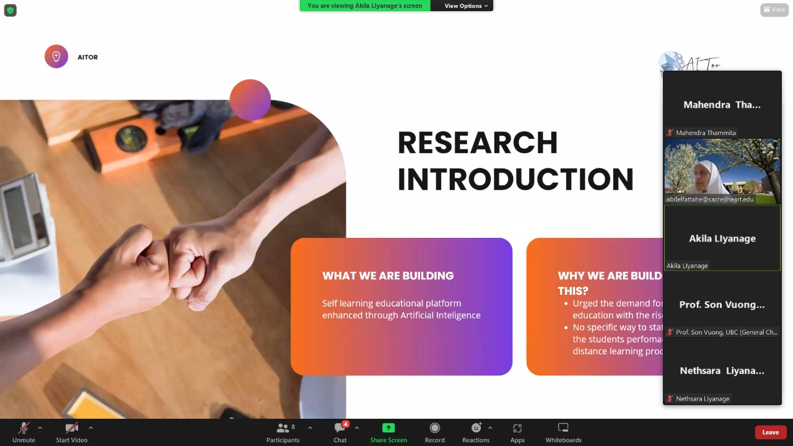

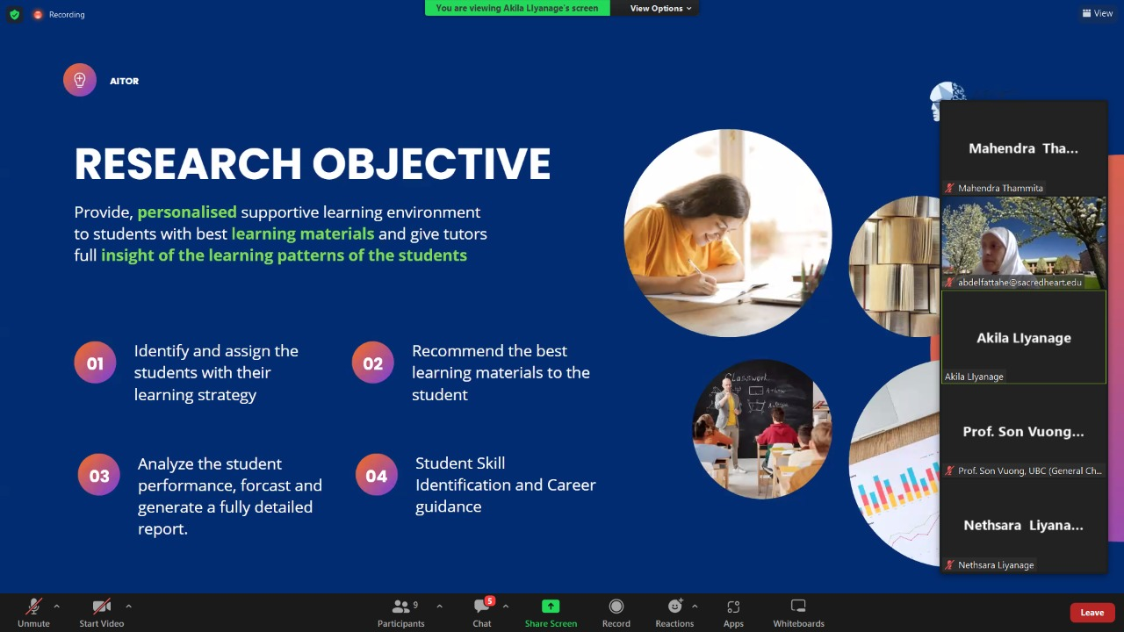

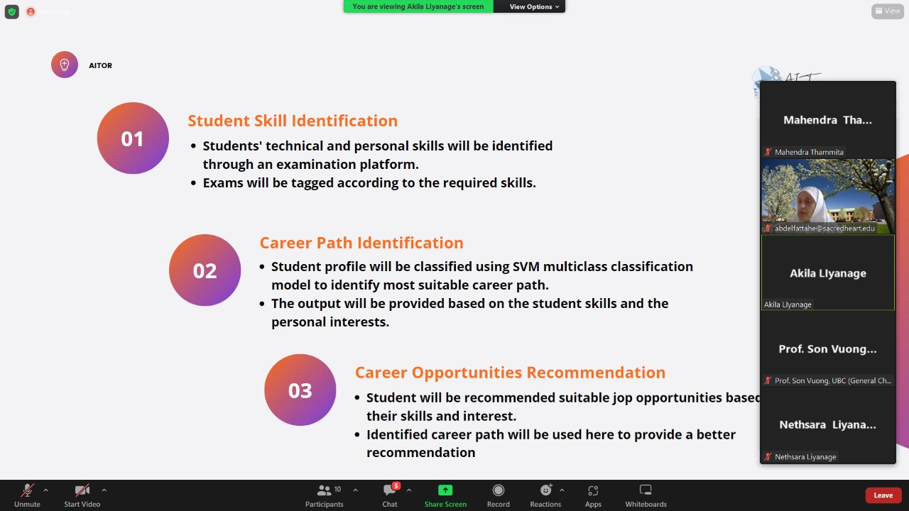

# Project planner

## Boards

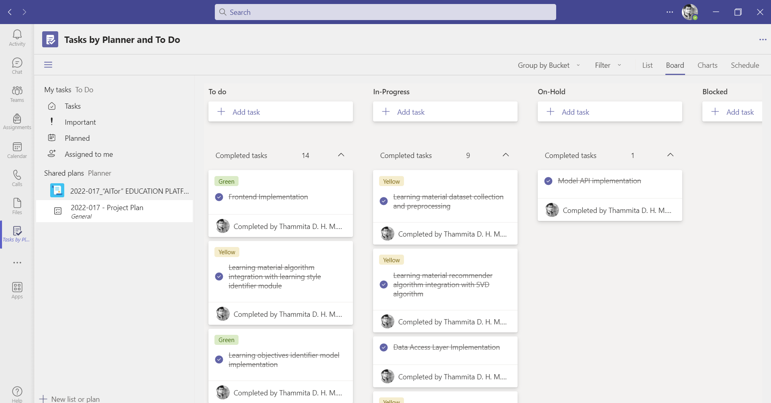

: Teams Planner Board : Grouped By Bucket

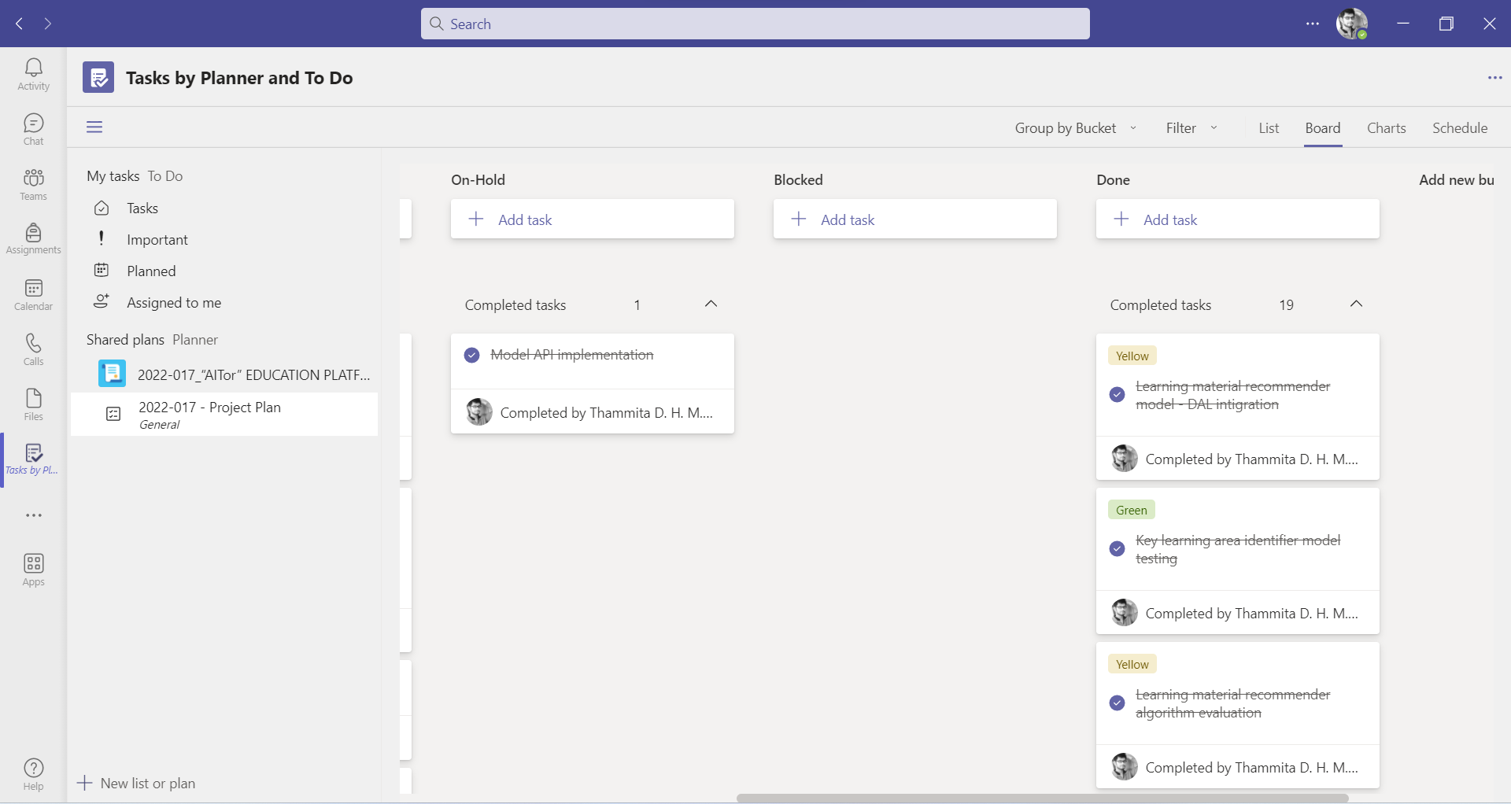

:Teams Planner Board : Grouped By Bucket - Completed

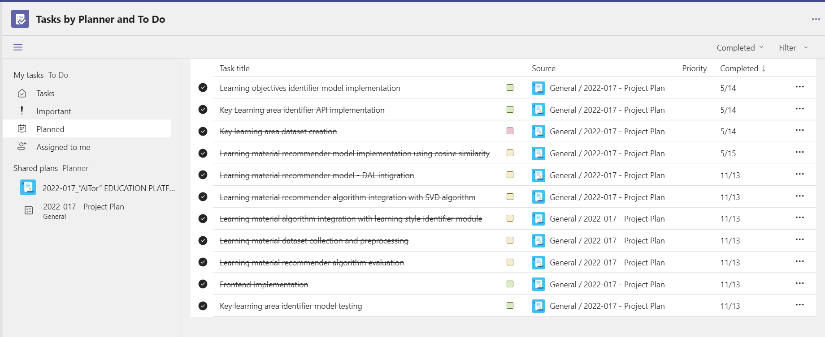

: Teams Planner Board : Completed Task List

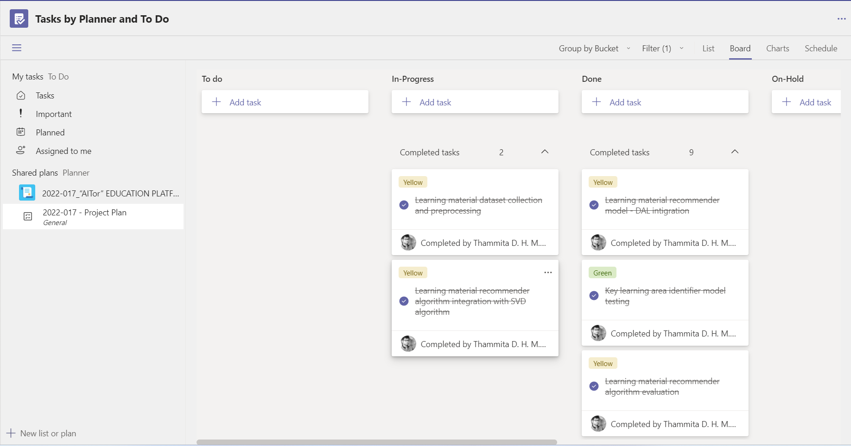

:Teams Planner Board : Completed Task List - Filter By Name - Thammita D.H.M.M.P

## Charts

### Overall Project Task Overview

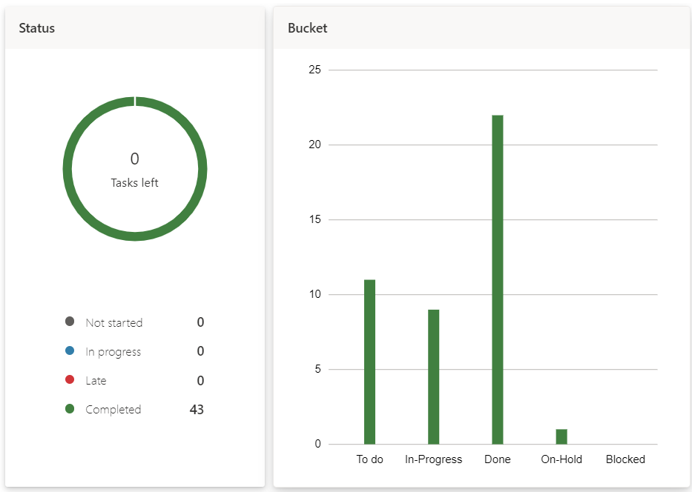

: Overall Project Task Overview - By Status and Bucket

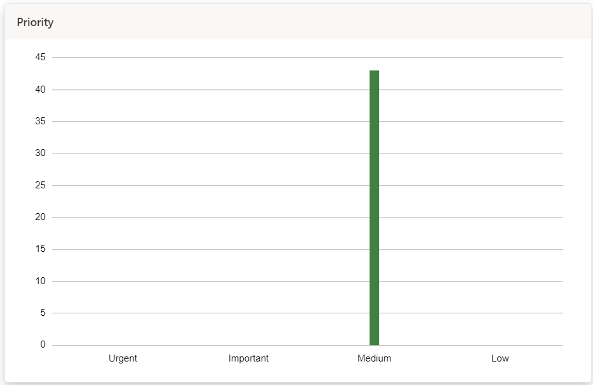

:Overall Project Task Overview - By Priority

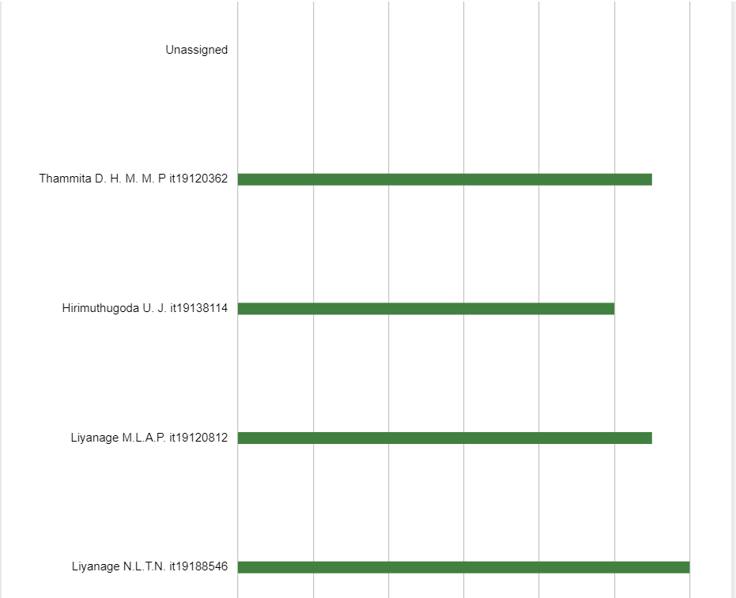

:Overall Project Task Overview - By Member

### Overview of Tasks Of Thammita D.H.M.M.P(IT19120362)

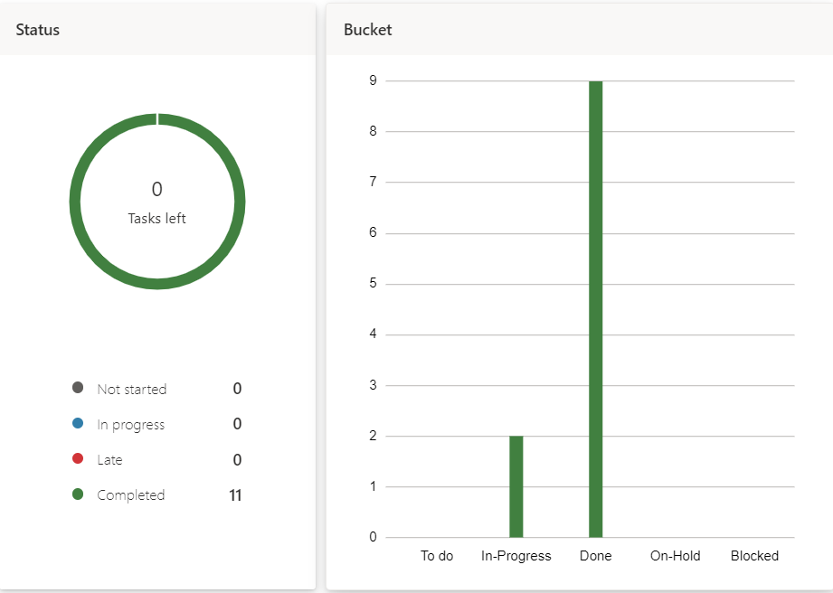

: 5.2.2. Overview of Tasks Of Thammita D.H.M.M.P(IT19120362) - By Status and Bucket

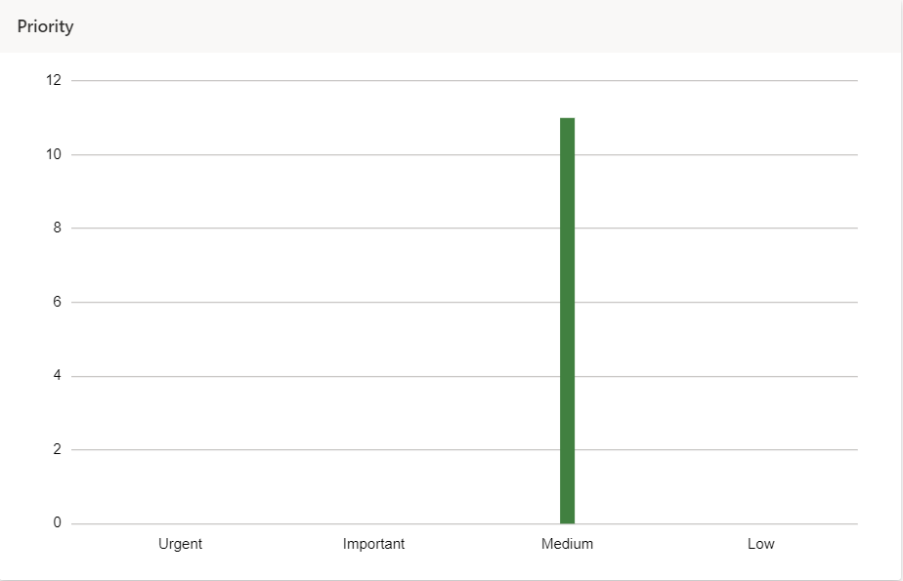

:Overview of Tasks of Thammita D.H.M.M.P(IT19120362) - By Priority

# Project Gantt chart

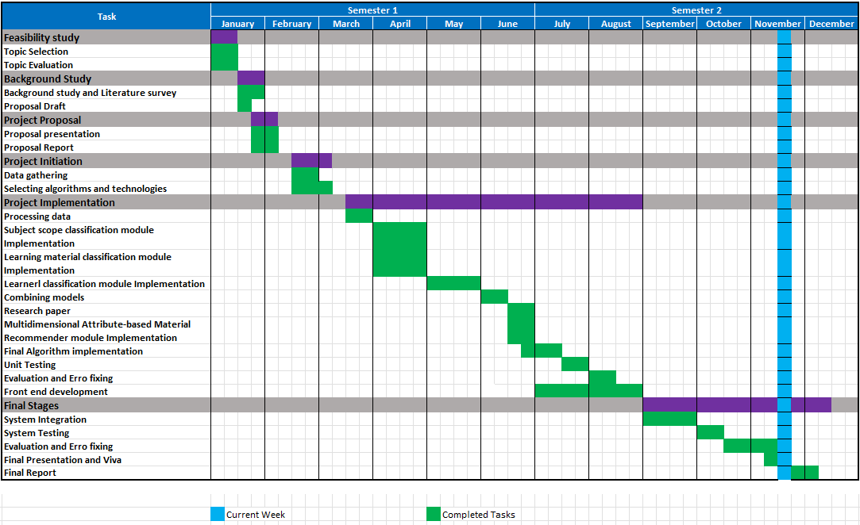

# Work breakdown chart

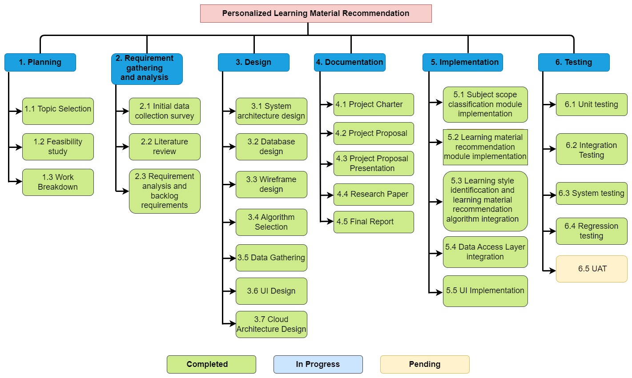

: Work Breakdown Structure

# User task allocation details

|  |  |  |
| --- | --- | --- |
| Allocated task | Predicted time | Actual time spent |
| Key learning area Identifier Dataset creation | 01/04/2022 – 30/04/2022 (30 days) | 20 days |
| Learning area Identifier algorithm implementation | 15/04/2022 – 30/04/2022 (15 days) | 21 days |
| Learning area Identifier API implementation | 01/05/2022 – 06/05/2022 (6 days) | 1 day |
| Learning material recommender model implementation using cosine similarity | 30/04/2022 – 11/05/2022 (11 days) | 6 days |
| Key learning area dataset creation | 05/04/2022 – 05/04/2022 (10 days) | 10 days |
| Learning material recommender model - DAL integration | 25/06/2022 – 30/06/2022 (5 days) | 2 days |
| Learning material algorithm integration with learning style identifier module | 30/06/2022 – 15/07/2022 (15 days) | 12days |
| Learning material dataset collection and preprocessing | 01/06/2022 – 01/07/2022 (30 days) | 30 days |
| Learning material recommender algorithm evaluation | 20/07/2022 – 31/07/2022 (21 days) | 25 days |
| Frontend Implementation | 15/07/2022 – 30/08/2022 (45 days) | 40 days |
| Key learning area identifier model testing | 15/08/2022 – 30/08/2022 (15 days) | 16 Days |
| Overall System Integration | 01/09/2022 – 20/09/2022 (20 days) | 30 days |

# GitLab Charts

## Commits To Master Branch

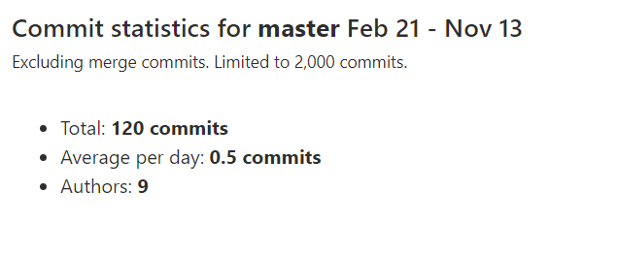

: Commit Statistics for Master Branch (Feb 21 - Nov 13)

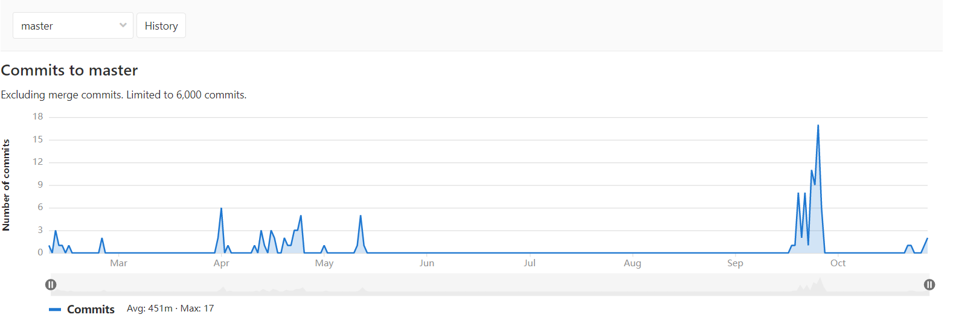

: Commits to Master Branch (Feb 21 - Nov 13)

## Commits By Thammita D.H.M.M.P(IT19120362)

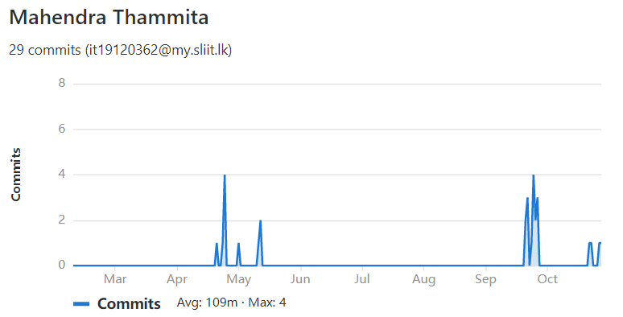

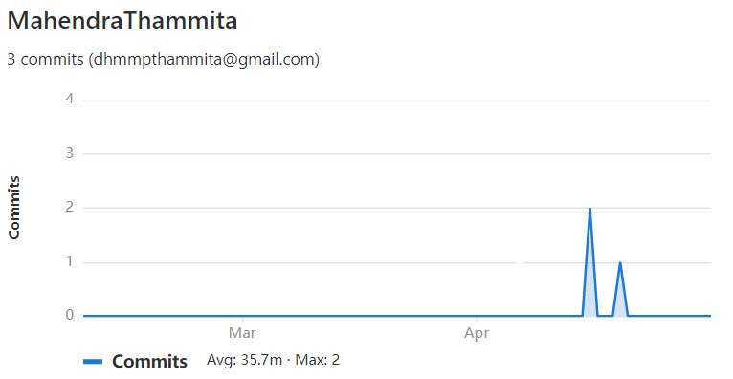

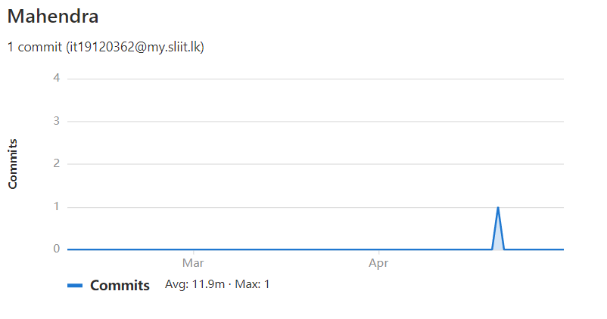

I have Used three user accounts were used to commit and screenshots commit charts of all user accounts are added in here

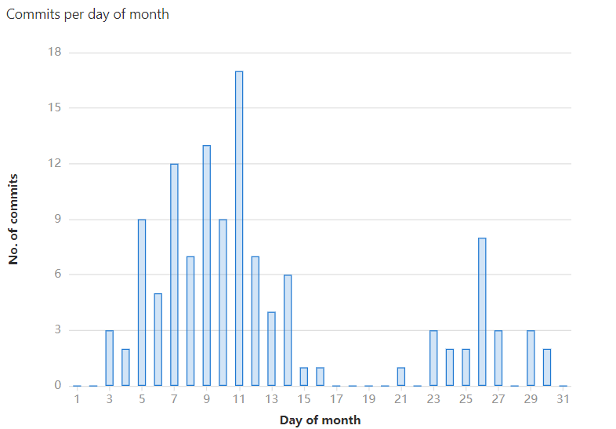

: 9:2 Commits Per Day of Month to Master Branch (Feb 21 - Nov 13)

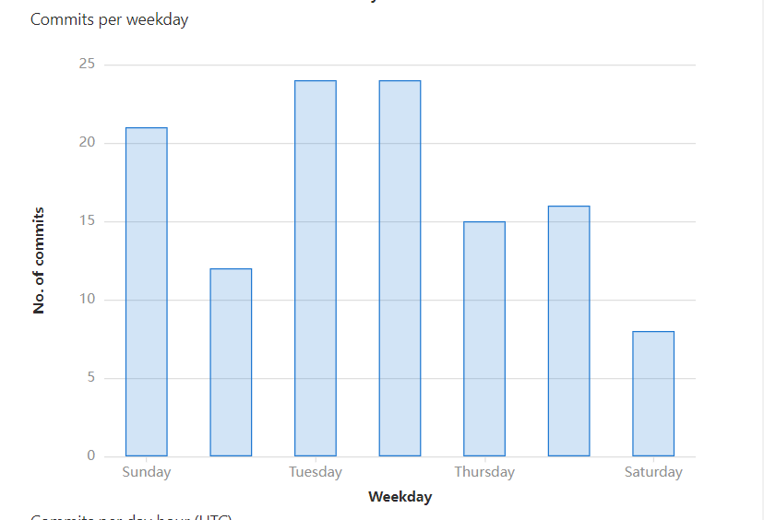

:Commits Per Weekday to Master Branch (Feb 21 - Nov 13)

## Commits To dev/it19120362

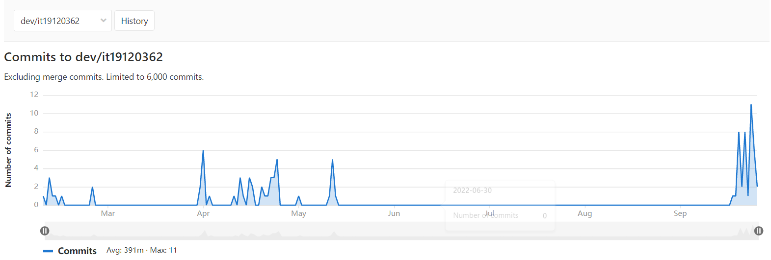

: Commits to dev/it19120362 Branch (Feb 21 - Nov 13)

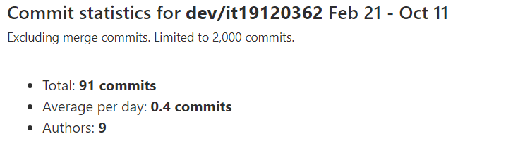

:9:3 Commits Statistics of dev/it19120362 Branch (Feb 21 - Nov 13)